Feature extraction

* Importance

1. Analysis the data
2. Develop a classification method

Should be independent from the location, direction and path of the gait

The effect elements for the gait recognition

* Time
* Footwear type
* Walking surface type
* Briefcase carrying condition
* Viewing angle
* Statistic method
* Time varying
* Max & Min

Find the max & 2nd max & min & 2nd min points, including the value and the index. Objects contain: acc, gyro, angle, velocity, position

* Frequency
* Time-frequency
* Wavelet
* time- and frequency-domain signal characteristics
* Trajectory (different type of motion considers different 2D view)
* Features of gait (Hesami et al, 2013)

1. Spatial-temporal: step length, step width, walking speed, cycle time
2. Kinematic: joint rotation of the hip, knee, angle, joint angles of the hip, knee, ankle, thigh, trunk, foot

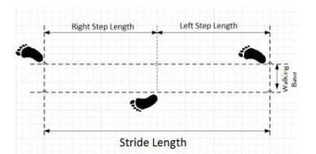 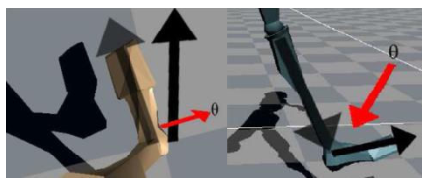

In this case, the gait parameters prefer to foot orientation and foot angle

* Features of path

(both in horizontal and vertical view)

The shape of the path: step over --- circle

walk --- straight

run --- zig-zag

* Phase space constraints (Lee et al, 1995)

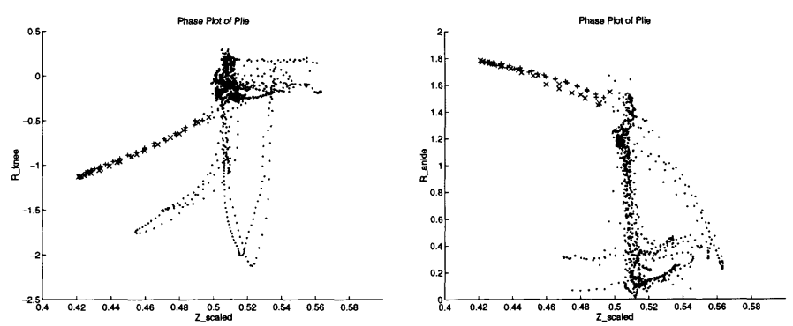

1. joint angles for lDOF joints (e.g. knee)
2. Euler angles for 3DOF joints (e.g. hip)
3. torso orientation
4. body-height-normalized torso height above the floor plane

* Machine learning
* PCA (principal component analysis) / KPCA (Kernel-based Principal Component Analysis)
* SVM (support vector machines)